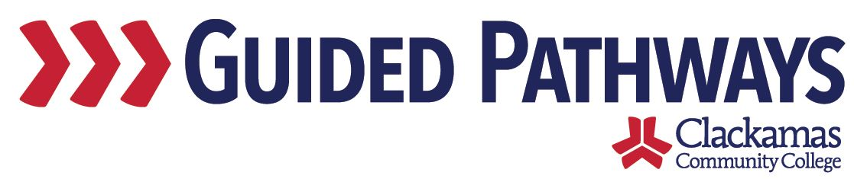
Guided Pathways Leadership Taskforce
Meeting Notes
April 5, 2021, 2:00–3:30 p.m. (Zoom)

- Welcome and check-in
- Welcome Stephanie Murphy
- Introductions

- Structure of future meetings
- Shorten to an hour, 2-3
- 3-3:30 would be a time for the leads to meet
- Agreement that this is a good idea
- Will start in May

- Prioritizing Professional Development Outcomes
- Groups generated a list, Dawn and Kelly compiled and categorized, the groups prioritized at the last meeting
- Dawn shared her screen to show the topics
- Three groups:
  - Group 1: Lisa, Stephanie, Tara, Brittany, Jennifer B, Sue M
  - Group 2: Dustin, Jaime, Lori, Sue, Lauren
  - Group 3: David, Lupe, Melissa, Jennifer A, Rylee
- https://docs.google.com/spreadsheets/d/12RPBVnOHTK9ha3gLD3blKpA0TO9Mqg9f9tVZbO-j8j0/edit#gid=0

- EFA 101 Share Out
- Sue Mach, Jennifer Bown, Yvonne Smith shared their experiences teaching EFA 101
  - Jennifer (STEM): synchronous class, weekly reflections, built career pathway plans, took a village to teach the class (total of 12-15 staff to put the class together), students loved it, got a taste for the different disciplines and then knew where to go next or who to contact
  - Sue (CACH): storytelling, legacy, reflection paper, many guests, interview, research, only four people
  - Yvonne (Social Sciences, Human Services, and Criminal Justice): thinking about people in societies, each discipline takes a different look at the topics, all online
- What could we do to better market the EFA courses? They don’t know what it is or where to find it – students aren’t sure what “EFA” is. Lori suggested developing some communication tracks before they register, couple plugs of where to start. Connecting with high school counselors. Market exploratory course to undecided students.
- Lori reminded everyone of the EFA website: https://www.clackamas.edu/academics/find-your-focus
- Sue, Jennifer, and Yvonne will forward the syllabi to Dustin and quotes and clips to Lori
- Dustin will share the syllabi with navigation and admission team

- Collaborative Planning Research Group findings
- Lauren shared an infographic and report
- Lauren will send to Kelly to share with the taskforce
- If there are questions, we may bring Lauren back for further discussion

- Review commitments and next steps
- Back in May with a shorter meeting
- Bring back results of the professional development discussion

